Security Auditing and Penetration Testing:

Note:
When operate penetration tester , it is imperative to understand that
When, how and why the security audits are performed.

Both security audits and penetration testing are separate types of assessment .
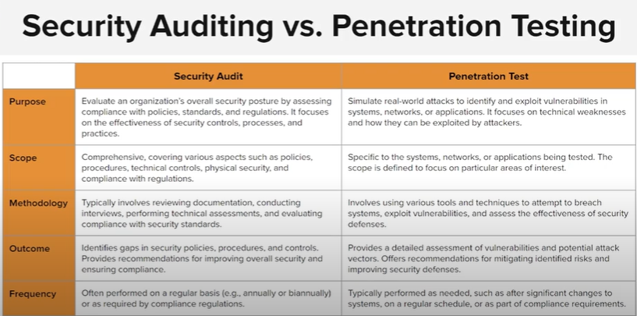

Sequential (Common) approach → Security audit is done first, and then a separate penetration testing team (specialized experts) performs the pentest.
Combined approach → Security audit is done first, and then the same team also performs the penetration test.

the sequential/separate-team approach is preferred.

Aspect | Security Audit 📝 | Penetration Test 🔐
What it is | A review/check of security policies, processes, and systems | A simulated attack to find real weaknesses
Focus | Compliance & controls | Exploiting vulnerabilities
Method | Checklist, interviews, document review, config check | Hacking techniques, tools, exploitation
Who does it | Auditors (compliance/security experts) | Ethical hackers / pentesters
Outcome | Report on gaps, compliance issues, and risks | Proof of vulnerabilities with attack paths
Goal | “Are we following the rules & policies?” | “Can someone actually break in?”

NOTE:
Compliance means that a company adheres to the applicable rules and laws.
Procedural controls = people & process rules (training, policies, procedures).
Technical controls = technology-based protections (firewalls, encryption, MFA).
Policy = what to do (the rule)
Procedure = how to do it (the steps)

Demo:
As we have external audit report and we set the weaknesses and the remediation to them I perform the penetration testing on it .
Planning and preparation
Information gathering and reconnaissance.
Penetration test execution
Finding and recommendations

